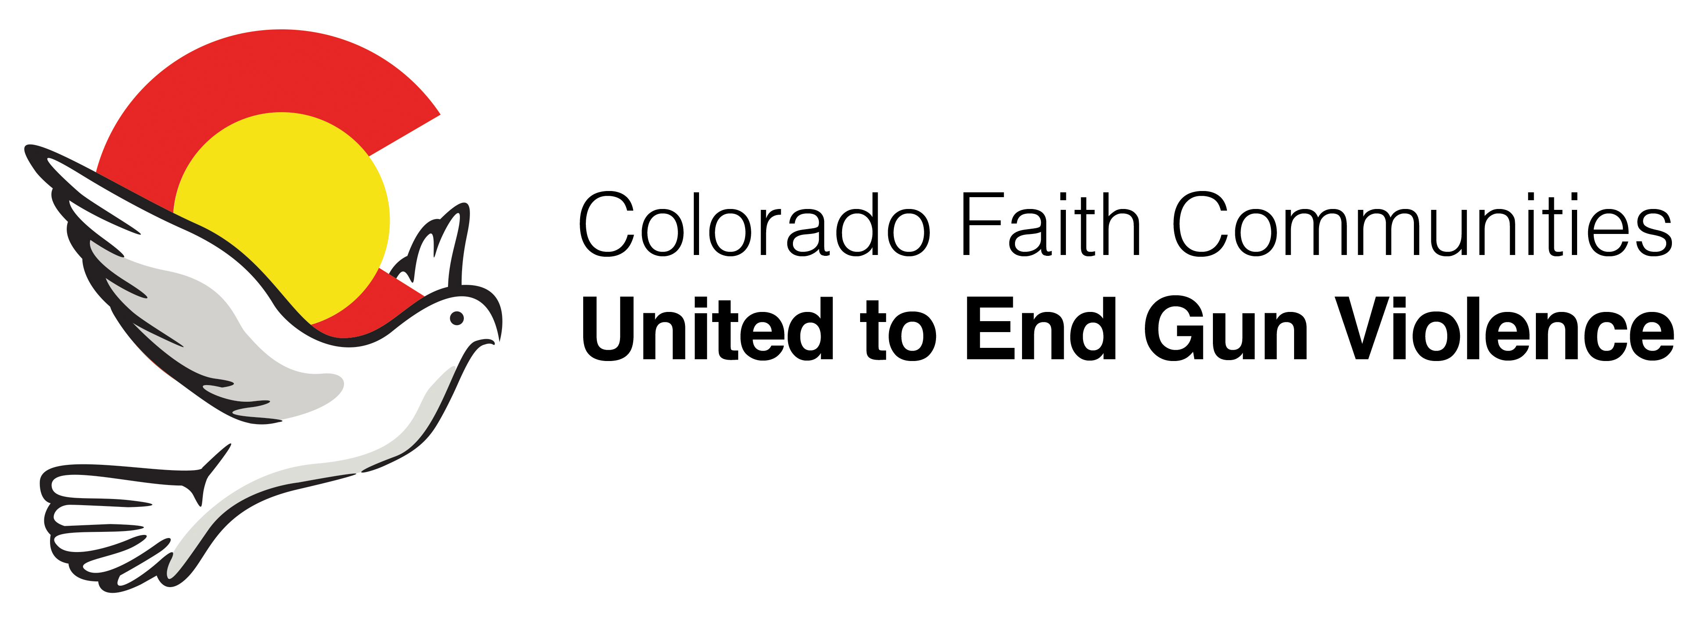

AN INVITATION TO HELP END GUN VIOLENCE IN COLORADO

"While we continue to pray for the families and friends of those who have perished,
we must also support our prayers with action."
-- Faiths United to Prevent Gun Violence

As members of diverse faith communities, we stand fast against the rising tide of gun violence and unite in the search for solutions to the epidemic of deaths and injuries caused by the improper use of firearms. We welcome new members at all times.

CFCU has a membership category for congregations and one for individuals not currently affiliated with a congregation or faith organization.

Member Congregations
- Your congregation or Social Justice/Action Committee determines that it wishes to support this effort.
- Your congregation appoints as many as two representatives who will:
- Attend CFCU general meetings
- Help develop and carry out programs and policies that support our mission through the work of our action teams
- Engage congregational members
- Facilitate your congregation’s annual contribution
- All members of your congregation are welcome at our meetings and are invited to help develop and carry out our programs and policies.
- Your congregation will make a modest contribution of $75 annually to support the administrative needs of the coalition. This is due in January of each year, and additional donations to support our work are always welcome.
- Many congregations have engaged their governing body to endorse the goals of Colorado Faith Communities United to End Gun Violence. A sample endorsing statement is attached. One advantage to taking this additional step is that it’s easier to engage your general church leadership, as well as your ordained ministers, rabbis, and faith leaders to speak about gun violence from a faith perspective, from the pulpit, and in other settings.

Friends of CFCU
- Friends of CFCU is a membership category for supporters of Colorado Faith Communities United to End Gun Violence (CFCU) who have no current congregational affiliation or have a congregational affiliation that is not an active member congregation of CFCU.

Questions? Contact cfcucolorado@gmail.com
cfcu-co.org

SAMPLE STATEMENT
FOR MEMBER CONGREGATIONS

We, the members of __________________________________________________________________ , affirm the sacred nature of human life and feel called to speak out and act when our blood or the blood of our neighbors is spilled. Aware of the continuing problem of gun violence in our state and country, we seek to give voice to all those who have been lost to gunfire, to their families and to their communities, and therefore endorse, as a congregation, the following statement:

We, as a member of Colorado Faith Communities United to End Gun Violence (CFCU), join and endorse the work of CFCU to promote legislation, policies and public programs designed to reduce the current levels of violence arising out of the improper use of firearms.

We call for the passage and preservation of common sense gun safety laws at the state and national level that will keep deadly firearms out of the hands of people who should not have them.

We call for a variety of public sector programs that help community leaders talk to their constituents about the costly and growing public health issue that gun violence has become, and how to deal with it.

And we call for more faith communities to join hands with us and the other members of Colorado Faith Communities United to End Gun Violence to raise our collective voice in a powerful and impassioned effort to build communities of peace.

Approved this day,

Name of Congregation:_________________________________________________________________________________________

Date:____________________________________________________

The following two members of our congregation are designated to serve as our representatives to CFCU:
- name__________________________________________ email _____________________________ phone # ________________

- name__________________________________________ email _____________________________ phone # ________________

Return to: cfcucolorado@gmail.com or
Susan Oakes – CFCU
c/o First Plymouth Congregational Church
3501 South Colorado Boulevard
Englewood, CO 80113

FRIENDS OF CFCU
REGISTRATION FORM

Friends of CFCU is a membership category for supporters of Colorado Faith Communities United to End Gun Violence (CFCU) who have no current congregational affiliation or have a congregational affiliation that is not an active member congregation of CFCU.

Friends of CFCU are invited to attend and participate in all CFCU general meetings and all Strategic Focus Area group meetings and programs. There are no membership fees and there are no voting privileges associated with the Friends category. Contributions to CFCU, however, are welcome.

Friends of CFCU understand that CFCU is a faith-based organization, representing a variety of faith traditions. While member congregations have different faith beliefs, all are united in the belief that human life is sacred and our belief systems call us to do everything possible to protect and preserve human life.

Friends of CFCU will be placed on the CFCU mailing list to receive all meeting announcements and notes. They will also comprise a separate “Friends Rapid Response Network” and will receive updates on legislative activities with suggestions that they contact legislators and/or attend legislative hearings to show support or opposition to gun legislation. They would also be free to present testimony on gun legislation as a representative of CFCU.

I understand and support the goals and values of CFCU and understand the role of Friends of CFCU.

__________________________________________________________________________________
Signature

Name:__________________________________________________________________________________________________________

Address:_______________________________________________________________________________________________________

E-Mail:_________________________________________________________ Phone # ____________________________________

Return to: cfcucolorado@gmail.com or
Susan Oakes – CFCU
c/o First Plymouth Congregational Church
3501 South Colorado Boulevard
Englewood, CO 80113

